**A**

**Synopsis**

**ON**

**Plant Irrigation System**

**By:**

Rakesh kumar khetwal-05215602816

Deepak Sharma-02115602816

Electronics and Communication & Engineering



**Department of Electronics and Communication**

**Northern India Engineering Colllege**

**Guru Gobind Singh Indraprastha University**

**Dwarka,New Delhi**

**Year(2016-2020)**

**Aim and Objective**

* To fulfill the water requirements of the plants and managing the supply of water through android application

**SOLUTION APPROACH**

**In this Project** **Soil Moisture Sensor** checks the moisture level in the soil and if moisture level is low then Arduino turn on the water pump to provide water to the plant via arduino code. The Water pump gets automatically turned off when system finds enough moisture in the soil.

If moisture is already present in soil then there is conduction between the two probes of Soil Moisture sensor and due to this conduction the Arduino Pin D7 remains Low. Now if there is no Moisture in soil then Pin D7 becomes High and with the help of android application we can control the amount of time required to water the plants by using different time limits such as 3,5,7 seconds. If moisture level reaches to 0-30 % then a message will appear to press the button so that we can water the plants for those specific seconds by clicking on the specified button. Similarly for different levels of moisture we can control the amount of time required to water the plants to reach their required level.

**Components Used**

* Arduino Uno
* Jumper wires
* 3-6V Water pump
* Water pipe
* Soil Moisture Sensor
* Resistors (1k, 10k)
* Android Bluetooth module
* Breadboard

**Circuit Diagram**

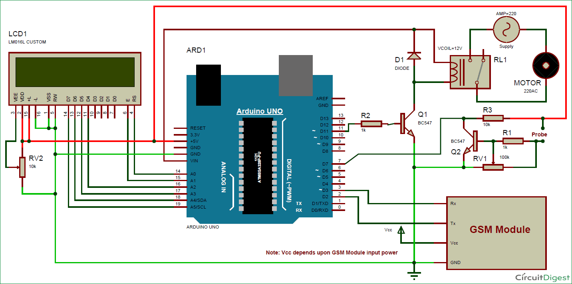

**Future Possibilites**

**We are thinking of integrating this machine collected data with machine learning algorithm. That’s why will need a cloud based database where the database can be stored.**

**This machine in its first phase will be setup on irrigation land for 1 year of time period, taking the reading in all weather condition for that particular area. Readings can include the temperature, soil moisture content, weather pattern in that area.**

**Outcome of this machine**

* Can predict the best time for irrigation.
* Can prevent the loss of water.
* Can predict the weather conditions in that area.
* Save money and time of farmers, so that it can be applied on other things. This machine can be helpful in acheiving dream of our Prime minister Narender Modi of doubling income of farmers.